26th Annual PACNY Environmental Conference
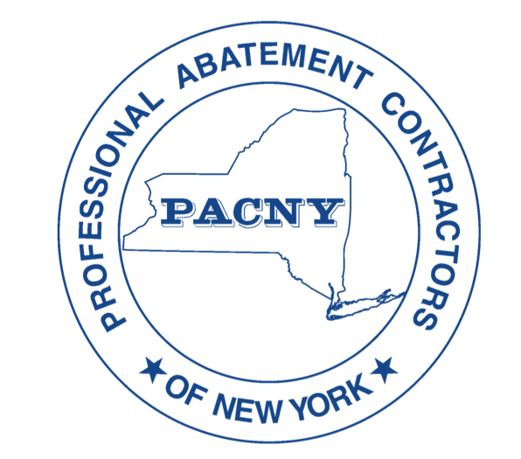
Turning Stone Resort & Casino, Verona, NY
Thursday March 16th and Friday, March 17th, 2023

Vendor Tradeshow Registration
Display your products and services in the Vendor Hall, adjacent to PACNY Conference Meeting Hall, to over 200 decision-makers in the asbestos/environmental industry. The PACNY conference averages over 200 attendees - the majority of attendees are decision makers/buyers.

Sponsor Options
Conference and Vendor Sponsors are the hosts (with no additional responsibilities) for the Thursday afternoon Vendor Reception held in the Vendor Hall. This reception is held at 4PM immediately after the last speaker’s presentation on Day 1 of the conference. Hot food, drinks, and adult beverages are provided at the reception. This is an outstanding opportunity to network and display your products/services to approximately 200 industry professionals! Last year the Vendor Reception was the highlight of the conference.

Sponsorship Level | Diamond | Emerald | Sapphire | Ruby
Cost of Vendor Sponsorship | $4,875 – only 2 available | $3,125 | $1,875 | $1,250
Benefits / Marketing Opportunities
Number of Display Table(s) in Vendor Hall | 2* | 2 * | 1 *
Number of Included Attendee Passes (Thur - Fri) | 6 | 5 | 3 | 2
Additional attendees per person | $195 per person | $195.00 pp | $195.00 pp | $195.00 pp
Adds in the Conference Flyer | Full Page Color** | Full Page B&W | 1/2 Page B&W | 1/4 Page B&W
Diamond Sponsor Selections  Available only to the 2 remaining Diamond Sponsors*** | Vendor Reception Sponsor  Education Sessions Sponsor  Keynote/Regulator Sponsor
* Table locations will be determined on the basis of when sponsorship is paid.

** First Diamond Sponsor will receive a full-page color ad on the back cover of the conference program. Second Diamond Sponsor will receive a full-page color ad on the inside front cover. Third Diamond Sponsor will receive a full-page color ad on the inside back cover.

*** Take advantage of these first come first served unique upsell opportunities available only to our Diamond Level sponsors. Our Diamond Level Sponsors may provide branded lanyards, banners, vendor bags, reception napkins etc. to promote their brand in a high-visibility way.

To secure your sponsorship please complete and fax / email the form below. Payment is due no later than February 15th.
For additional information please call Lisa Brown @ (315) 480-9894 / email pacnyinfo@gmail.com.

Last year’s conference was very popular with all vendors. Foot traffic in the Vendor Hall was very high. Registration, and all coffee breaks will once again be held in the Vendor Hall (adjacent to Conference Meeting Hall) on both days. Also, vendor punch cards will be distributed to all attendees. Attendees are encouraged to visit each vendor by having the cards “punched” to be eligible for a drawing to win an Amazon Gift Card (winner must be present to claim prize). Lastly, the Thursday afternoon Vendor Reception is also held in the Vendor Hall.
26th Annual PACNY Conference Sponsorship Registration Form
Email completed form to: Lisa Brown @ (315) 480-9894 / email pacnyinfo@gmail.com.

Diamond Sponsor _______
Emerald Sponsor _______
Sapphire Sponsor _______
Ruby Sponsor _______

__________________________________________________________________________________________________
Firm Name Signature Printed Name

__________________________________________________________________________________________________

Telephone Number Fax Number Email Address

Attendees Thursday Friday

___________________________ _________ _________

___________________________ __________ _________

___________________________ __________ _________

___________________________ __________ __________

___________________________ __________ _________

___________________________ __________ __________

Note: Additional Attendees cost is $195.00 per person.

PACNY, PO Box 3148, Syracuse, NY 13220, Phone (315) 480-9894 email: pacnyinfo@gmail.com www.PACNY.org

